

**كلية العلوم الحاسوبية والمعلوماتية**

Faculty of CSI

**Hotel reservation System**

*Students:*

|  |  |
| --- | --- |
| Bader safwan albahnasi | 201920297 |
|  |  |

*Supervisor:*

Dr. Ala Ali Abuthawabeh

*Amman - Jordan*

*2023/2024*

**Table of Contents**

1.1 Problem Statement and project Scope page 1

1.2 Project Plan and Schedule

2. System Analysis page 2

2.1 Functional Requirements

2.2 Use Case Diagram

3. System Design page 3

3.1 Class Diagram

3.2 ER-Diagram (if a database will be used)

* 1. Problem Statement and project Scope

The system has been facing problems due to its paper-based appointment

system. With the increase in the number of patients visiting, it has

become diﬃcult to manage the appointment system manually. Recording

of appointments and creating registers by pen and paper has become a

It’s a hotel reservation system that software that allows hotels to manage reservations and take bookings and appointments also enables potential guests to reserve and pay for a service

* 1. Project Plan and Schedule

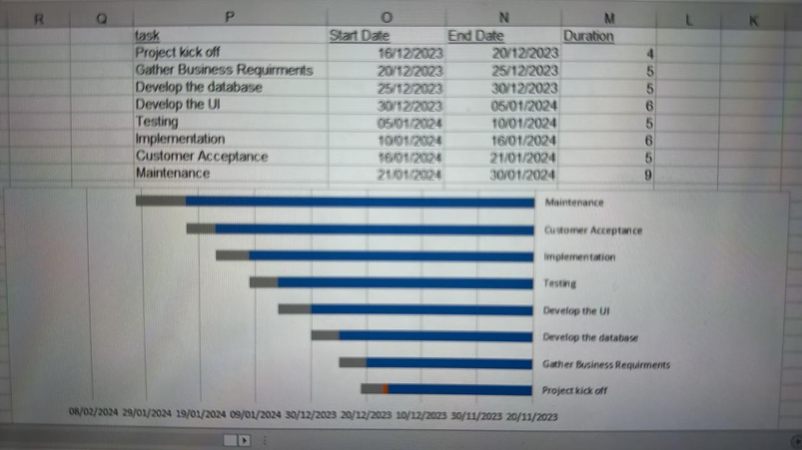

Figure 1: Gantt Chart of project

* 1. 2. System Analysis

2.1 Functional Requirements

1.1: book a hotel room

1.2: modify the reservation details

1.3: cancel the reservation

2.1: browse hotel options

2.2: filter hotel options based on user preferences

3.1:generate a confirmation receipt for the reservation

2.2 Use Case Diagram

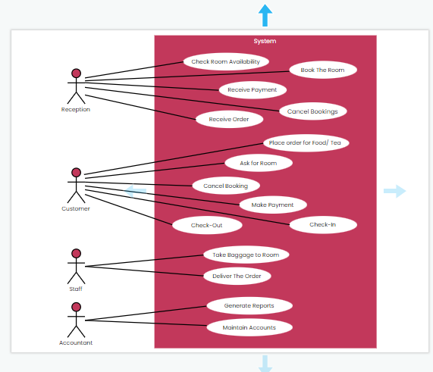

Figure 2: Use Case diagram of system

3. System Design

3.1 Class Diagram

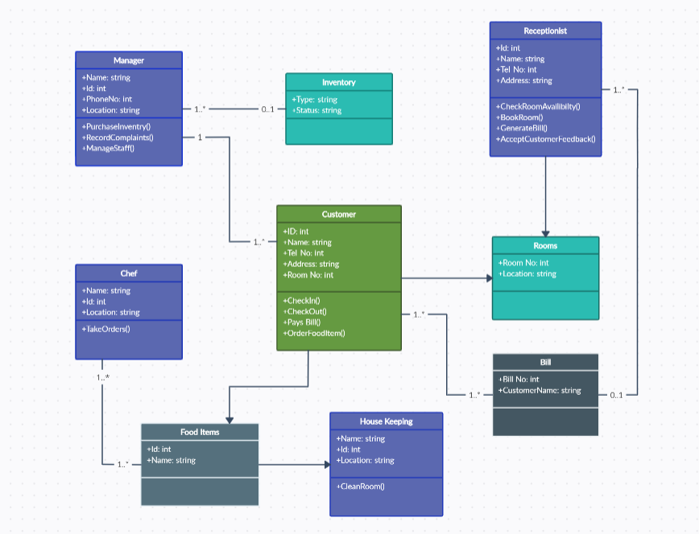

Figure 3: Class diagram of Appointment system

3.2 ER-Diagram

